A
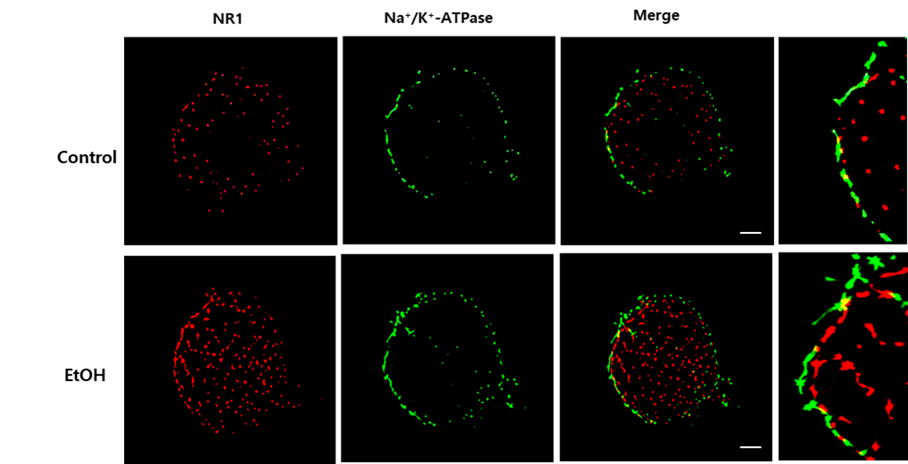
Figure S1. Effect of ethanol on NR1 accumulation on membrane. A Cells were incubated with EtOH for 12 h and immunostained with NR1 and Na⁺/K⁺-ATPase antibodies. Na⁺/K⁺-ATPase (green) and NR1 (red) were visualized with SRRF imaging system. Scale bars are 8 μm (magnification, × 1,000). Immunofluorescence images are representative.

A
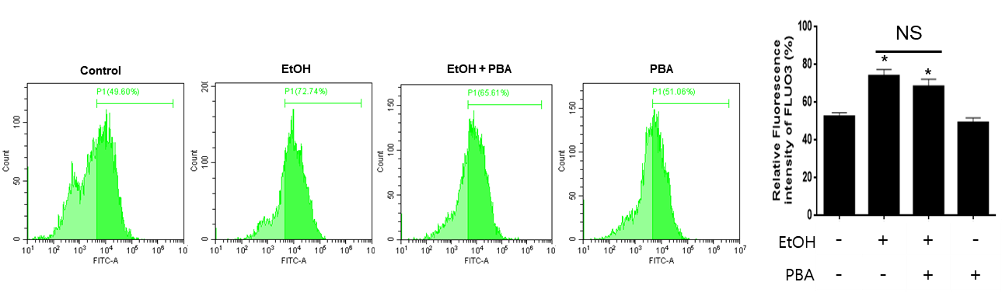
Figure S2. Effect of PBA on intracellular calcium concentration. A Cells were pretreated with PBA (2.5 mM) for 30 min, and then exposed to EtOH for 24 h. Cells were loaded with Fluo 3-AM (2 μM) for 30 min, and the amount of intracellular calcium was measured by using flow cytometry. Data are presented as a mean ± S.E.M. n = 3. NS is no significant difference between groups. *p < 0.05 versus control.

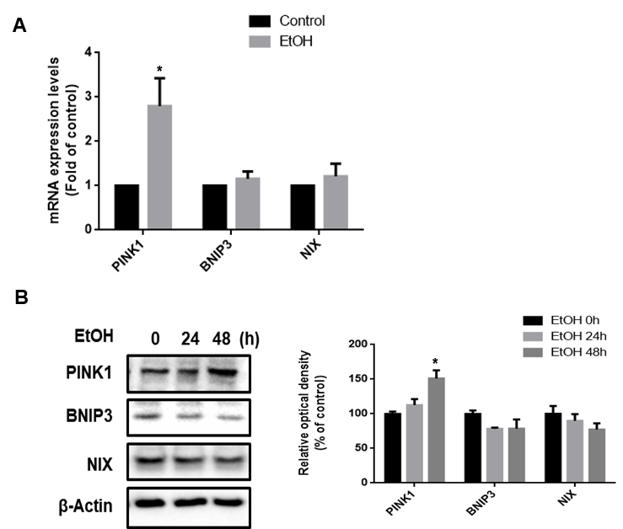
Figure S3 Effect of ethanol on mRNA and protein expression of mitophagy regulator genes. A Cells were treated with EtOH (200 mM) for 24 h. mRNA expressions of PINK1, BNIP3 and NIX were analyzed by quantitative real time PCR. Data were normalized by the ACTB mRNA expression level. Data are presented as a mean ± S.E.M. n = 3. B Cells were exposed to EtOH (200 mM) for 0-48 h. PINK1, BNIP3 and NIX were detected by western blot. β-Actin was used as a loading control. Data are presented as a mean ± S.E.M. n = 3. All blot images are representative. *p < 0.05 versus control.

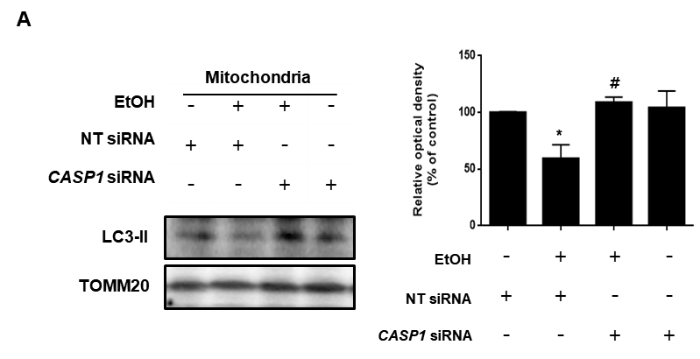
Figure S4 Effect of caspase-1 silencing on ethanol-reduced LC3-II expression in mitochondria. A Cells were transfected with CASP1 siRNA or NT siRNA for 24 h prior to ethanol exposure for 48 h. LC3-II expression was measured by western blotting. β-Actin was used as a loading control. Data are presented as a mean ± S.E.M. n = 3. All blot images are representative. *p < 0.05 versus control, #p < 0.05 versus EtOH.

A
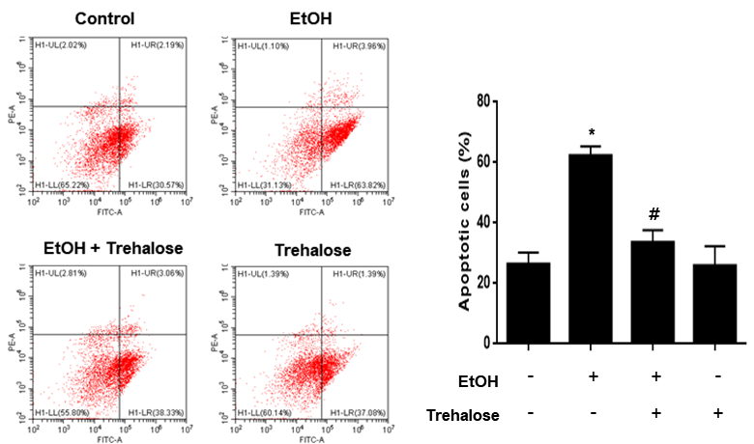
Figure S5 Effect of trehalose on ethanol-induced neuronal apoptosis. A Cells were pretreated with trehalose (2 μM) for 30 min prior to EtOH treatment for 72 h. Apoptotic cells were detected by annexin V/ PI staining. Data are presented as a mean ± S.E.M. n = 3. The data are representative. *p < 0.05 versus control, #p < 0.05 versus EtOH.

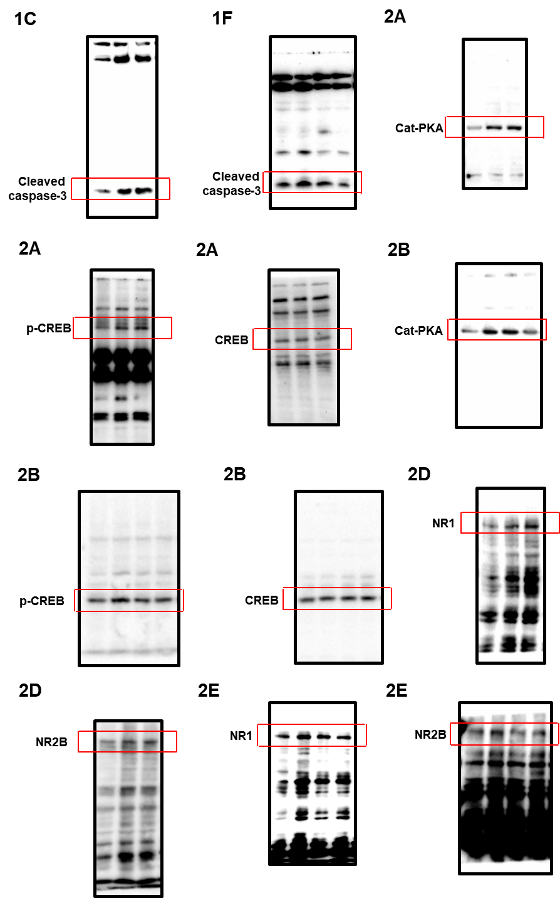
Fig. S6 Law images in Fig.1C-2E.

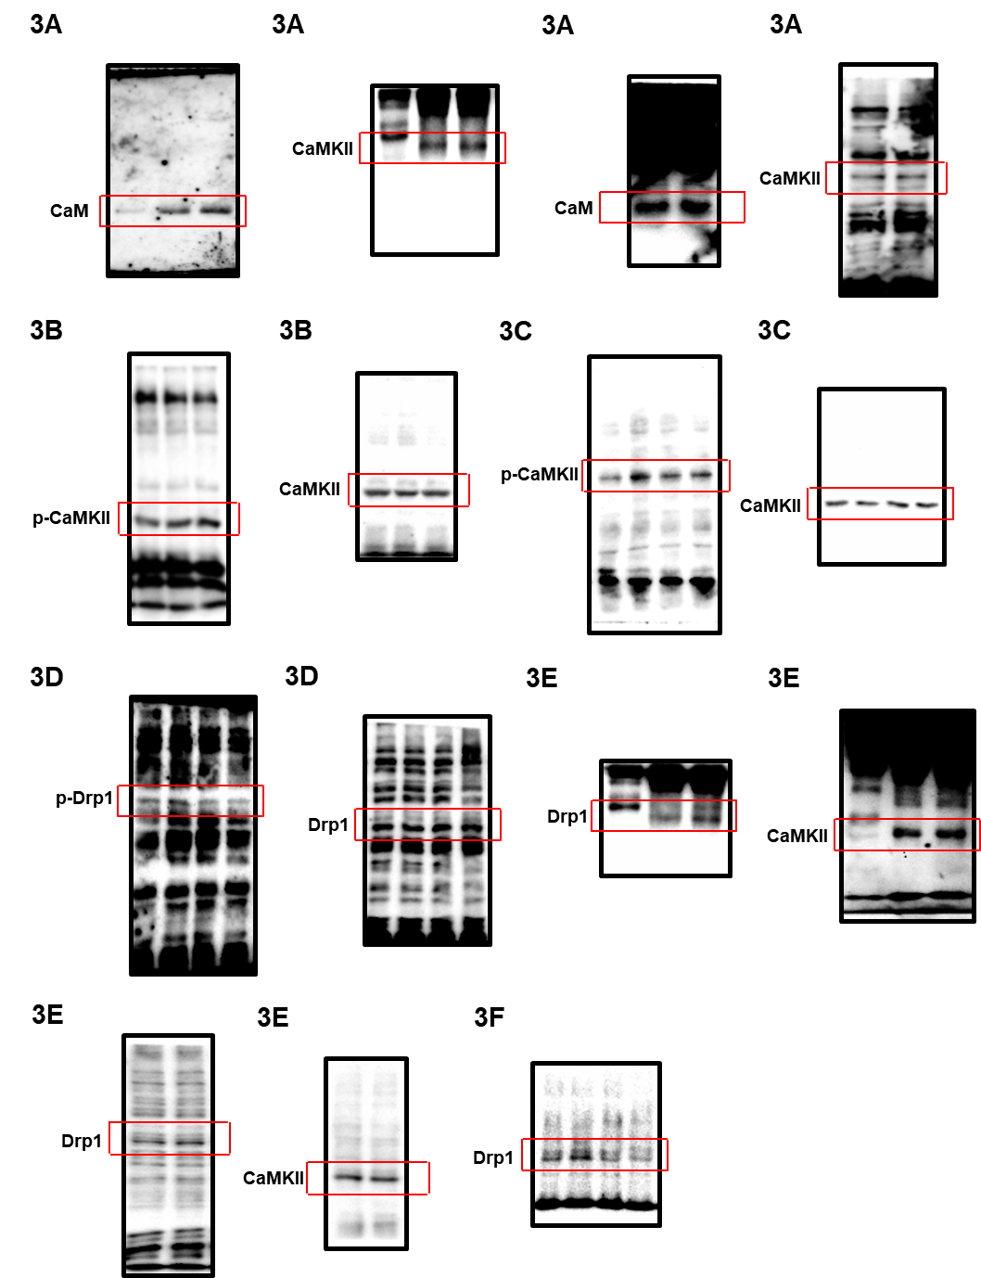
Fig. S7 Law images in Fig. 3A-3F.

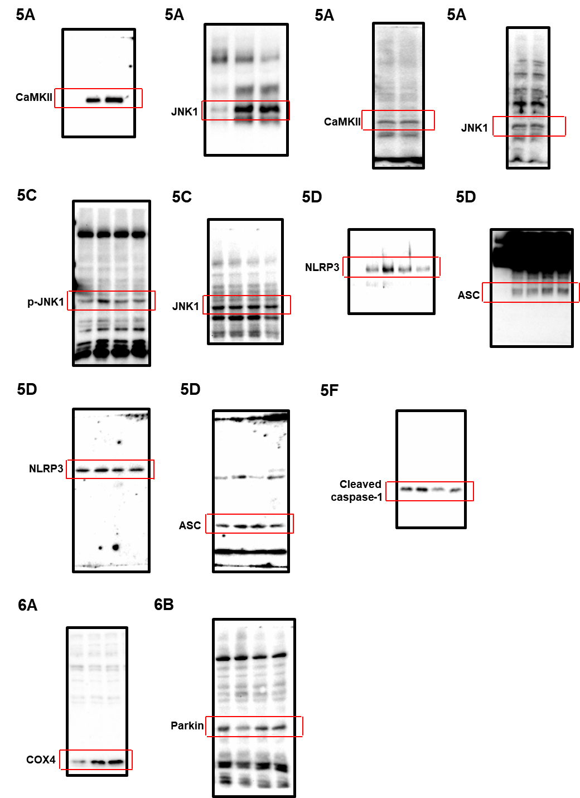
Fig. S8 Law images in Fig. 5A-6B.

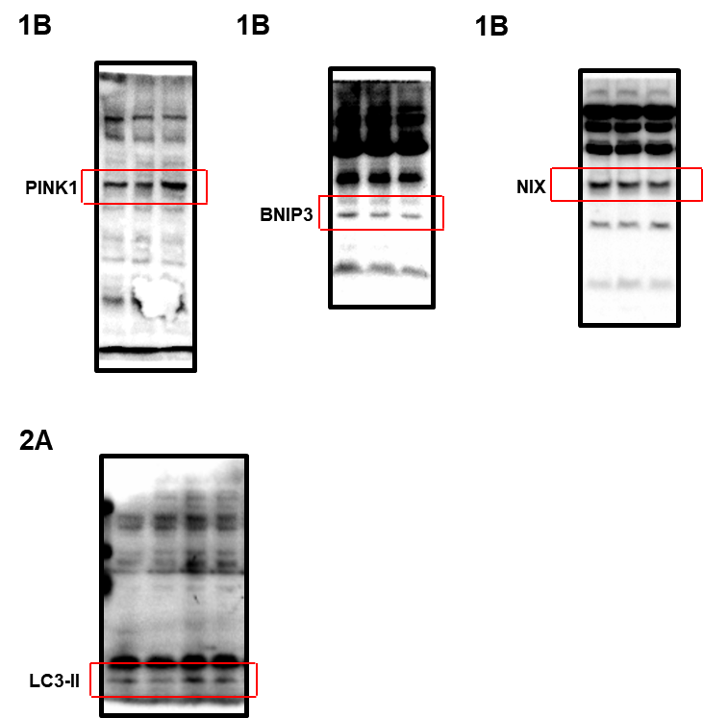
Fig. S9 Law images in Fig. S1B-S2A.

Table S1. Sequences of primers used for RT-PCR and real-time PCR
Gene | Identification | Sequence (5'-3')
GRIN1 | Forward | CTACCGCATACCCGTGCTG
GRIN1 | Reverse | GCATCATCTCAAACCACACGC
GRIN2A | Forward | TGGCCTCACCGGGTATGATT
GRIN2A | Reverse | CAATGCCGTCCCTCACTCTC
GRIN2B | Forward | TCTGACCGGAAGATCCAGGG
GRIN2B | Reverse | TCCATGATGTTGAGCATTACGG
GRIN2D | Forward | GAGGAAAGGCCGTTTGTCATC
GRIN2D | Reverse | TGTGGGTTCGGTTGAGCTG
PINK1 | Forward | GCCTCATCGAGGAAAAACAGG
PINK1 | Reverse | GTCTCGTGTCCAACGGGTC
BNIP3 | Forward | GCCATCGGATTGGGGATCTAT
BNIP3 | Reverse | GCCACCCCAGGATCTAACAG
NIX | Forward | GGACTCGGCTTGTTGTGTTG
NIX | Reverse | TAGCTCCACCCAGGAACTGT
ACTB | Forward | AACCGCGAGAAGATGACC
ACTB | Reverse | AGCAGCCGTGGCCATCTC

Table S2. Sequences of siRNAs used for gene silencing

Target gene | Sequences 5’-3’ | Manufacturer
CASP1 | GGAAGACUCAUUGAACAUA  GAUGGUAGAGCGCAGAUGC  CCGCAAGGUUCGAUUUUCA  GAGUGACUUUGACAAGAUG | Dharmacon
CREB1 | GAGAGAGGUCCGUCUAAUG  UAGUACAGCUGCCCAAUGG  CAACUCCAAUUUACCAAAC  GCCCAGCCAUCAGUUAUUC | Dharmacon
JNK1 | GGAGCUCAAGGAAUAGUAU  AUACUAUUCCUUGAGCUCC | Cell Signaling Technology
Non-targeting | UAGCGACUAAACACAUCAA  UUGAUGUGUUUAGUCGCUA | Dharmacon

Table S3. Information numbers of genes and proteins.

Gene | Information number | Protein name | Information number
GRIN1 | NM_000832.7 | CaM | P0DP23
GRIN2A | NM_000833.5 | CaMKII | Q9UQM7
GRIN2B | NM_000834.5 | CREB | P16220
GRIN2D | NM_000836.2 | JNK1 | P45983
PINK1 | NM_032409.3 | BNIP3 | Q12983
BNIP3 | NM_004052.3 | NIX | O60238
NIX | NM_001330491.2 | β-Actin | P60709
 |  | Drp1 | O00429
 |  | PINK1 | Q9BXM7
 |  | Caspase-3 | P42574
 |  | TOMM20 | Q15388
 |  | Parkin | O60260
 |  | NR2B | Q13224
 |  | NR1 | Q05586
 |  | COX4 | P13073
 |  | NLRP3 | Q96P20
 |  | Caspase-1 | P29452
 |  | LC3 | Q9GZQ8

